Day 1: Assignment-1 (Introduction of Java)
Name: Suraj Arya | PRN No.: STT-25128071920
Q1. Find out differences between JDK and JRE and JVM? 1. Find out differences between JDK and JRE and JVM?
Ans: The JDK (Java Development Kit) is used for development and includes tools along with the JRE and JVM.
The JRE (Java Runtime Environment) is used for running Java programs, and the JVM (Java Virtual Machine) is the engine that executes the bytecode.
Q2. Why Java called a platform-independent language?
Ans: Java is called a platform-independent language because of its unique two-step execution process involving bytecode and the Java Virtual Machine (JVM), which enables the principle of "Write Once, Run Anywhere" (WORA).
Q3. Write a basic Java program that prints: “Welcome to Java Programming”.
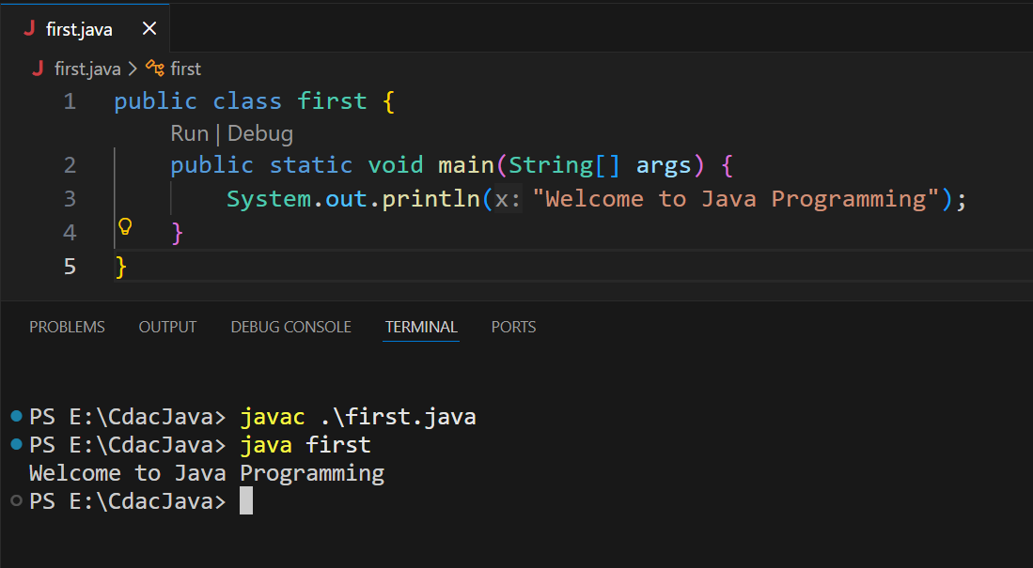
Ans:

Q4. Write a basic Java program that prints: “This is my first Java program”.
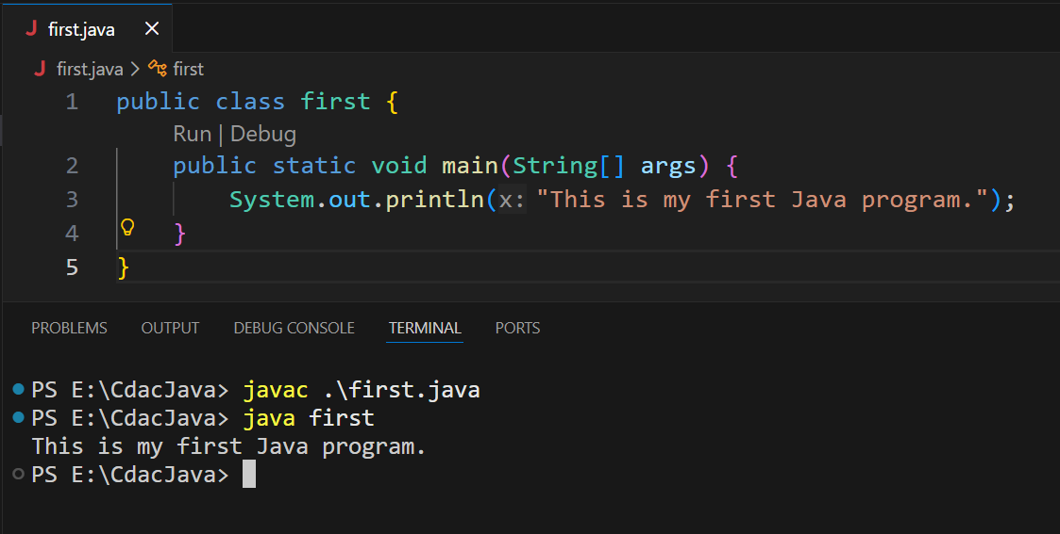
Ans:

Q5. 5. What will happen if the main method is removed from a Java program?
Note: Use Notepad and command prompt to run java code.
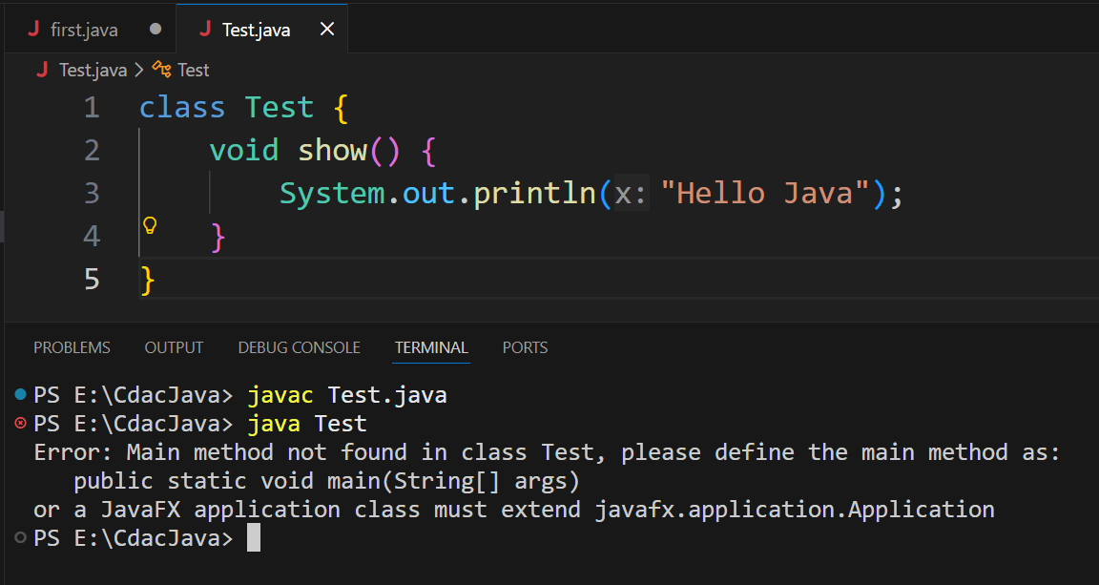
Ans: If the main method is removed, the program will compile, but it will not run because the JVM cannot find the entry point and throws a “main method not found” error.

Q6. Write down difference between all Java LTS version?
Version | Release Year | Key Features / Improvements
Java 8 | 2014 | Introduced Lambda expressions, Streams API, Functional interfaces, Date & Time API — major modern Java foundation.
Java 11 | 2018 | Added HTTP Client API, new String methods, local-variable syntax for lambdas, removed some old modules (like Java EE) — better modern standard libs.
Java 17 | 2021 | Brought Sealed Classes, pattern matching improvements, strong encapsulation of internal APIs, and performance enhancements.
Java 21 | 2023 | Major improvements like Virtual Threads (Project Loom), more advanced pattern matching, and performance & scalability boosts.
Ans:

